CodeIgniter
POS
Developed By: Wai Phyo San Tin
Start Date: 15 Apr 2014
Last Modified Date: 15 Apr 2014

Revision History
Effective Date | Summary of Changes
04 Aug 2013 | - Javascript Form Builder (v 1.0.0.0)
25 Aug 2013 | - InputKeyValidator (v 1.0.0.0)
02 Dec 2013 | - Date Time Differences Calculation

This book is dedicated to my friends
who want to start PHP development with framework

Introduction
If we look at the current trend of web developments, we can see that desktop like application such as facebook is more popular. Websites are aiming to provide desktop like feature in the browser. We have to use techniques such as “javascripts”, “jQuery” and “Ajax” to avoid page refreshing and dynamic form building.
I am now working at software industry and server side languages such as “PHP” are used just for interacting with database. The rest will be take care by “javascript”. We are using javascript to avoid page loading and provide more interactive web application to user.
In this book, I demonstrated the development of “javascript, jQuery and jQuery plugin”. More version and deep down example concerning such technology will be coming.
Let me know if you have further questions.
You can always contact me on www.facebook.com/waiphyosantin
Happy Programming!

Table of Contents
Contents
1 Javascript Form Builder (v 1.0.0.0) 6
1.1 Set up 6
1.2 formbuilder.js 8
1.3 index.php 11
1.4 Demonstration 12
2 InputKeyValidator (v 1.0.0.0) 14
2.1 Set Up 14
2.2 jquery.inputKeyValidator.js 16
2.3 index.php 18
2.4 Demonstration 20
3. Date Time Differences Calculation 21

Prerequisites

1 Downloading and setting up website

1.1 Downloading
Please go to http://ellislab.com/codeigniter to download the latest codeigniter framework. In my case, I download version 2.1.4. I got the file CodeIgniter_2.1.4.zip.

1.2 Setting up the website
- In the webroot of your server, unzip the file. The webroot will be as follow
- “wamp” – “C:\wamp\www\”
- “xampp” – “C:\xampp\htdocs\”
- Since I am using “wamp” server, I will unzip the file in “C:\wamp\www\” folder.
- Rename the folder as “cipos”.
- You will see the following in your folder
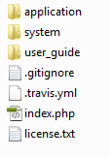
fig (1.2.1)
- Type http://localhost/cipos/ in your browser and you will see the following
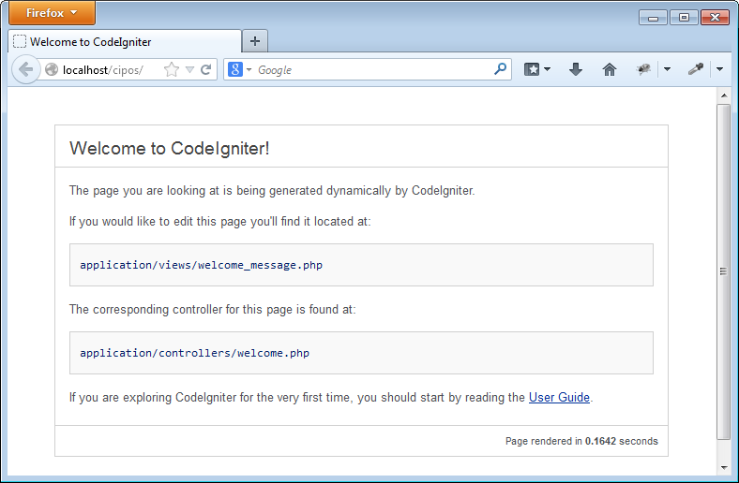
fig (1.2.2)

2 Developing template

2.1 Starting with the draft
The following is the draft template I have in mind. Don’t put it in the project yet. That is just a skeleton. We will divide the following into separate template components and put in our CI project in next step.
Template reference: www.dynamicdrive.com/style/layouts/item/css-liquid-layout-21-fixed-fluid/
<html>
<head>
<title>CI POS</title>
</head>
<body>
<div id="maincontainer">

<div id="topsection"></div>

<div id="contentwrapper">
<div id="contentcolumn">
<div class="innertube">
</div><!-- end of "innertube" -->
</div><!-- end of "contentcolumn" -->
</div><!-- end of "contentwrapper" -->

<div id="leftcolumn">
<ul id="menu">
<li><a href="#">Home</a></li>
<li><a href="#">Log In</a></li>
<li><a href="#">Item Entry</a></li>
<li><a href="#">Item Display</a></li>
<li><a href="#">Shopping Cart</a></li>
<li><a href="#">Check Out</a></li>
</ul>
</div>

<div id="footer"></div>

</div><!-- end of "maincontainer" -->
</body>
</html>
fig (2.1.1)

